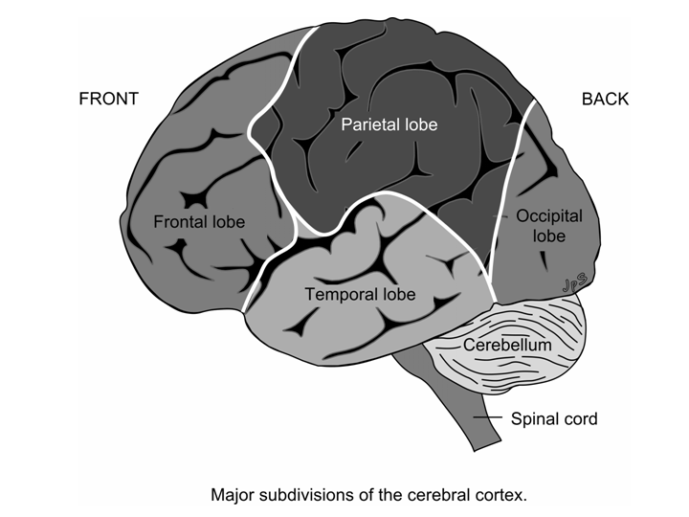
cerebrum: the largest structure of the brain; containing the cerebral cortex (the outer layer), which is made of gray matter, and an inner core composed of white matter (myelinated nerve fibers and gray basal ganglia); divided into a number of regions known as lobes.
cerebellum: is the main structure in the hindbrain, situated at the base of the brain, at the top of the spinal cord. The cerebellum controls our balance and postural stability, and is involved in motor coordination - not, it appears, in the initial learning of motor skills, but in the performance and improvement of learned motor skills. Some regions of the cerebellum are especially vulnerable to the effects of chronic alcoholism. The hindbrain, although far from the frontal lobes, is connected to those regions, most especially through the pons and the thalamus. Recent rat studies have also suggested that the cerebellum may be involved in some way in remembering strong emotions, in particular, in the consolidation of long-term memories of fear. There is also growing evidence that the cerebellum might also be involved in processing speech and language.
gyrus: a fold or convolution in the cerebrum (compare sulcus)
sulcus: a cleft or fissure in the cerebrum (compare gyrus)
frontal lobe: the frontal lobes (left and right) are situated at the "front" of the cortex, i.e. behind the forehead. They are the largest of the lobes in the cerebrum, and may be thought of as the "highest" part of our brain. The frontal lobes are critical for those faculties that humans regard as special to our species - reasoning, planning, attention, some aspects of language. Women have up to 15% more brain cell density in the frontal lobe, but with age, appear to shed cells more rapidly from this area than men. By old age, the density is similar for both sexes.
parietal lobe: one of the lobes of the cerebrum, situated at the top, behind the frontal lobe. The primary sensory area is located in the parietal lobe - this is where nerve impulses carrying sensations of pain, temperature, touch, and pressure come. Areas in the parietal lobe are also involved in spatial orientation, speech and language development, and attention.
temporal lobe: one of the lobes of the cerebrum, situated below the frontal and parietal lobes, and above the hindbrain. The temporal lobe is primarily concerned with sensory experience - specifically, with hearing, and with the integration of information from multiple senses. Part of the temporal lobe also plays a role in memory processing. Patients with damaged temporal lobes appear to have impaired lexical retrieval of names of living things.

occipital lobe: one of the lobes of the cerebrum, situated at the back of the skull, and above the hindbrain. It borders with the parietal lobe (from which it is not clearly demarcated) and the temporal lobe. The occipital lobe contains the primary visual cortex, where visual information is processed.
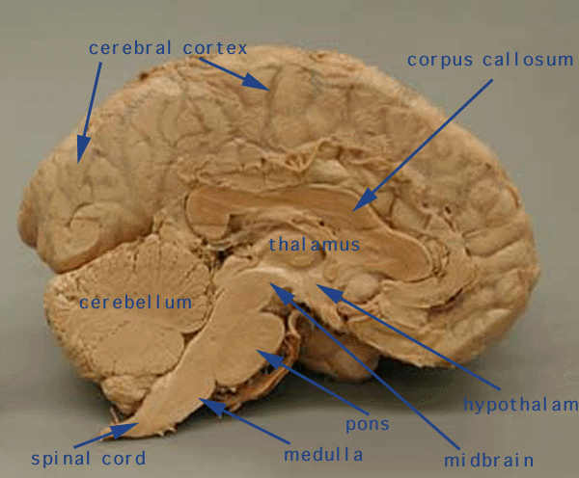

thalamus: means "inner chamber", and accordingly is located deep within the cerebrum. It is an egg-shaped structure lying at the very top of the brain stem, above the hypothalamus. The thalamus relays all information received from the senses (except smell) to the various processing centers in the cerebral cortex. Recent research also suggests that the thalamus regulates the electrical rhythms that parts of the brain use to communicate with each other. It has been speculated that tips of the tongue experiences (when only part of a memory is recalled) may occur when the rhythms don't synchronize with the regions properly - which would put these memory failures at the door of the thalamus. The thalamus also seems to be involved in memory consolidation processes that occur during sleep.
pons: short for pons varolii; a "bridge" (pons is Latin for bridge) of nerve fibers connecting the cerebellum and the medulla oblongata with other regions of the brain, most particularly with the frontal lobe.
prefrontal cortex: is the area of the brain at the very front of the frontal lobes. It is involved in "executive functions", such as working memory, decision-making, planning and judgment. Prefrontal regions appear to be particularly sensitive to the effects of aging. It is thought that the reduced ability to recall the context of memories that occurs with advancing age, is evidence that the prefrontal cortex is also critical for context processing - a process involved in many cognitive functions. A recent study has also revealed that emotional stimuli and attentional functions are integrated in a specific part of the prefrontal cortex - the anterior cingulate (located between the right and left halves).
premotor cortex: is part of the motor cortex, located in the frontal lobe. It is adjacent to the primary motor area. It is located primarily in the precentral gyrus and caudal portions of the superior frontal gyrus and the middle frontal gyrus.
corpus callosum: the main "bridge" between the left and right cerebral hemispheres; a broad bundle of myelinated fibers (white matter) carrying information from regions in one lobe to similarly placed regions in the opposing lobe. There are some 300 million fibers in the average corpus callosum. Cutting the corpus callosum prevents communication between the hemispheres (creating the well-known "split-brain" cases), and is used in severe cases of epilepsy.

Broca's region: is located in the frontal lobe, and, for most people, the left hemisphere (some left-handers have this area in the right hemisphere). Originally thought to be "the" speech center, it is now understood that a number of regions of the brain are involved in language behavior. More recently, Broca's area has been implicated in music processing, leading some researchers to suggest music may be processed as a language. Imaging studies have revealed that professional musicians trained at an early age have an increased volume of gray matter in Broca's area. Broca's area is part of a language and music processing network that includes Wernicke's area, the superior temporal sulcus, Heschl's gyrus, planum polare, planum temporale, and the anterior superior insular cortices
Wernicke's area: is one of the primary auditory areas. The structure includes part of the supramarginal gyrus, the angular gyrus, the superior temporal gyrus and the middle temporal gyrus. It is involved in language comprehension - specifically, allows you to understand the meaning of spoken words.
hippocampus: means "sea horse", and is named for its shape. It is one of the oldest parts of the brain, and is buried deep inside, within the limbic lobe. The hippocampus is important for the forming, and perhaps long-term storage, of associative and episodic memories. Specifically, the hippocampus has been implicated in (among other things) the encoding of face-name associations, the retrieval of face-name associations, the encoding of events, the recall of personal memories in response to smells. It may also be involved in the processes by which memories are consolidated during sleep.

